HCMUS-FIT Mascot Designing
Võ Thiện Trí Nhân
November 14 2025
1 Description
This mascot design is inspired by the Macintosh (Apple), with the screen displaying a smiling face against a Windows-style blue death screen background. In addition to that, I added ”404” to refer to the website’s common error: 404
Not Found. [1]
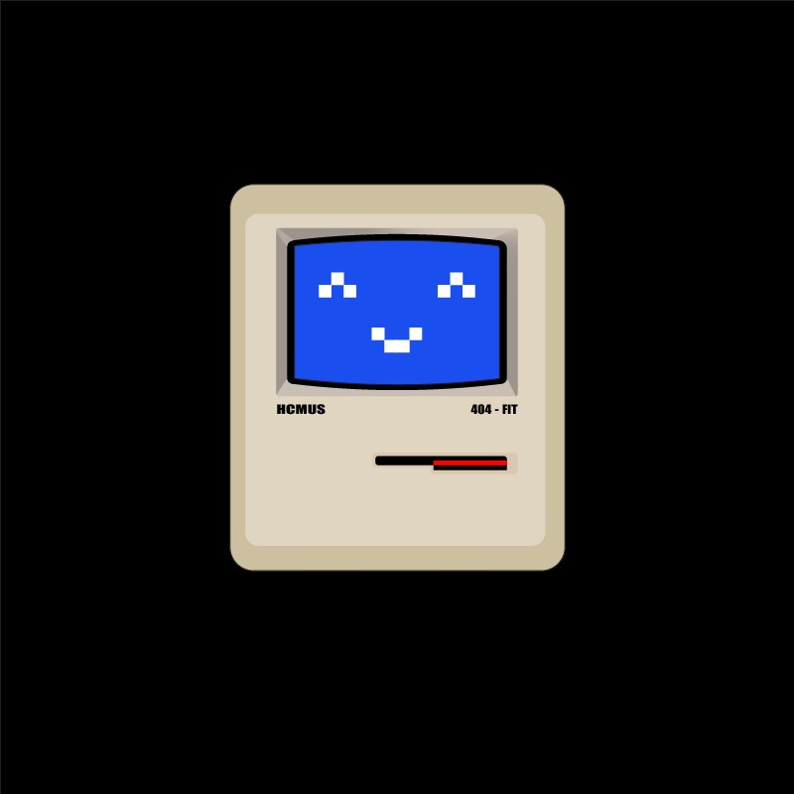
Figure 1: Mascot Design
1

